CSXXX (**Day** and **Time** of the Class**)**

**COMPUTER SCIENCE CAPSTONE COURSE**

# San Francisco Bay University, Fremont, CA

# MIDTERM or FINAL REPORT

# Summer 2024



# Prof. Ahmed Banafa

# Name of the Project

**Submission Date**

# Team Members

|  |  |
| --- | --- |
| Student Name | Student ID |
| Student Name | Student ID |
| Student Name | Student ID |
| Student Name | Student ID |

**Table of Content**

1. **Abstract 3**
2. **Introduction 4**

2.1 Project Overview

2.2 Target Audience

2.3 Key Functionalities Developed

1. **Project Methodology 6**

3.1 Development Approach

3.2 Development Tools and Technologies

3.3 Development Workflow

**4. System Architecture 9**

4.1 System Architecture Diagram

**5. User Interface (UI) Design 13**

5.1 Key Features of UI Design

5.2 Design Principles

5.3 UI Screenshots

5.4 Design Choices and User Experience (UX)

5.5 UI Frameworks and Libraries

**6. Backend Development 23**

6.1 Backend Functionalities

6.2 Database and Data Models

6.3 Backend Components

**7. Security Considerations 29**

7.1 Secure Password Storage

7.2 Addition Security measures

**8. Conclusion 31**

**9. References 32**

**Abstract**

The Fit & Fun React application is an innovative project aimed at providing users with an AI-powered workout companion. The application offers a seamless blend of user-friendly interfaces, efficient backend processes, and essential security measures to ensure a comprehensive fitness experience. This report outlines the development stages, from initial concept to final deployment, highlighting the methodologies, system architecture, user interface design, backend development, and security considerations. The project demonstrates the practical application of modern web development technologies and best practices, resulting in a robust and scalable fitness application.

**Introduction**

**2.1 Project Overview**

In today's fast-paced world, maintaining a healthy lifestyle is more crucial than ever. Fit & Fun is designed to meet this need by offering a personalized and interactive workout experience. The application leverages the power of AI to create tailored workout plans, provide motivational quotes, and facilitate user engagement through a seamless interface. The core objective of this project is to integrate modern web development practices with cutting-edge AI technology to create a user-centric fitness application.

This report delves into the various aspects of the Fit & Fun application, including the development process, system architecture, user interface design, backend integration, and security measures. By documenting these elements, the report aims to provide a comprehensive overview of the project's scope, objectives, and outcomes. The application serves as a testament to the potential of combining technology and fitness, offering users a unique and effective way to achieve their health goals.

**2.2 Target Audience**

Fit & Fun caters to a broad audience with an interest in fitness, encompassing a wide range of users. Seasoned fitness enthusiasts will find value in Fit & Fun's ability to optimize their existing routines, providing them with tools to track their progress, analyze their performance data, and set personalized goals. For beginners embarking on their fitness journeys, Fit & Fun offers a supportive and encouraging environment. The application's intuitive interface and planned AI features are designed to be user-friendly and accessible, regardless of technical background. By providing guided workout routines, educational resources, and motivational support, Fit & Fun empowers beginners to confidently take their first steps towards a healthier lifestyle.

**2.3 Key Functionalities Developed**

Fit & Fun caters to a broad audience with an interest in fitness, encompassing a wide range of users. Seasoned fitness enthusiasts will find value in Fit & Fun's ability to optimize their existing routines, providing them with tools to track their progress, analyze their performance data, and set personalized goals. For beginners embarking on their fitness journeys, Fit & Fun offers a supportive and encouraging environment. The application's intuitive interface and planned AI features are designed to be user-friendly and accessible, regardless of technical background. By providing guided workout routines, educational resources, and motivational support, Fit & Fun empowers beginners to confidently take their first steps towards a healthier lifestyle.

**Project Methodology**

Fit & Fun caters to a broad audience with an interest in fitness, encompassing a wide range of users. Seasoned fitness enthusiasts will find value in Fit & Fun's ability to optimize their existing routines, providing them with tools to track their progress, analyze their performance data, and set personalized goals. For beginners embarking on their fitness journeys, Fit & Fun offers a supportive and encouraging environment. The application's intuitive interface and planned AI features are designed to be user-friendly and accessible, regardless of technical background. By providing guided workout routines, educational resources, and motivational support, Fit & Fun empowers beginners to confidently take their first steps towards a healthier lifestyle.

**3.1 Development Approach**

We adopted an Agile development methodology, a flexible and iterative approach that prioritizes continuous adaptation and responsiveness to feedback. This methodology proved instrumental in tackling the ever-evolving landscape of user needs and technological advancements. Agile principles permeated our development cycle, emphasizing the following core tenets:

* **Incremental Development:** We opted for a phased development approach, delivering core functionalities in manageable iterations. This allowed for continuous user feedback integration and facilitated course correction throughout the development process.
* **Prioritization and Backlog Management:** User stories were meticulously prioritized based on their impact and user value. A comprehensive backlog served as a dynamic roadmap, constantly updated to reflect the evolving priorities and project requirements.
* **Rapid Prototyping and Iterative Design:** Functional prototypes were developed rapidly to visualize concepts and gather user feedback early in the development cycle. This iterative design process ensured that the final application effectively addressed user needs and fostered an intuitive user experience.
* **Continuous Integration and Delivery (CI/CD):** We implemented a robust CI/CD pipeline to automate code testing, integration, and deployment. This streamlined process facilitated frequent code updates and minimized the risk of regressions. The CI/CD pipeline also ensured a consistent and reliable development environment, fostering collaboration and code quality.

By embracing the Agile methodology, we cultivated a dynamic development environment that fostered continuous improvement and adaptation. This approach enabled us to deliver a user-centric application that aligns with evolving user requirements and industry trends.

### 3.2 Development Tools & Technologies: MERN Stack for Efficiency and Scalability

The MERN stack, a potent combination of technologies, served as the foundation for the Fit & Fun application. This powerful stack provided the necessary tools and frameworks to build a robust, scalable, and feature-rich application. Let's explore the specific components of the MERN stack employed in our development process:

* **MongoDB:** As our NoSQL database solution, MongoDB offered flexibility, scalability, and a schema-less design. This provided the perfect platform to store and manage user data, workout routines, and progress tracking information with ease.
* **Express.js:** This versatile Node.js web framework provided a robust foundation for building our application's back-end server. Express.js facilitated efficient routing, data handling, and API development, streamlining the communication between the front-end and back-end components.
* **React.js:** Leveraging React.js, a popular JavaScript library for building user interfaces, we constructed a dynamic and interactive front-end for the Fit & Fun application. React's component-based architecture fostered modularity and code reusability, streamlining the development process and ensuring maintainability.
* **Node.js:** As a JavaScript runtime environment, Node.js empowered us to execute JavaScript code outside of a web browser. This enabled us to create a server-side environment that seamlessly interacted with the React.js front-end and managed database interactions using MongoDB.

The synergistic combination of these MERN stack technologies provided a powerful and adaptable development environment. This strategic selection ensured efficient development, scalability for future growth, and a user-friendly experience for our target audience.

### 3.3 Development Workflow: Streamlined Collaboration and Quality Control

A well-defined development workflow ensured seamless collaboration, efficient code review, and rigorous quality control throughout the development process. Here's a breakdown of the key stages in our workflow:

* **Planning and Requirement Gathering:** The initial phase involved meticulous planning and requirement gathering. User stories were meticulously documented, outlining user needs and desired functionalities. This comprehensive understanding of user expectations guided the development process and ensured the final application aligned with user goals.
* **Version Control with Git:** Git, a distributed version control system, played a pivotal role in managing code changes, facilitating collaboration, and enabling efficient version tracking. This empowered team members to work on different aspects of the application simultaneously while maintaining a centralized repository for code updates and version control.
* **Development and Code Review:** Individual developers worked on assigned tasks, implementing functionalities based on user stories and technical specifications. Regular code review sessions fostered collaboration, ensured code quality, and identified potential bugs or areas for improvement early in the development cycle.
* **Testing and Deployment:** Rigorous testing procedures evaluated the functionality, performance, and user experience of the application. Unit testing ensured individual components functioned as intended, while integration testing verified seamless interaction between different parts of the application. Upon successful testing, the application was deployed to a secure web hosting environment, making it accessible to users.

**System Architecture Design**

**4.1 System Design Diagram**

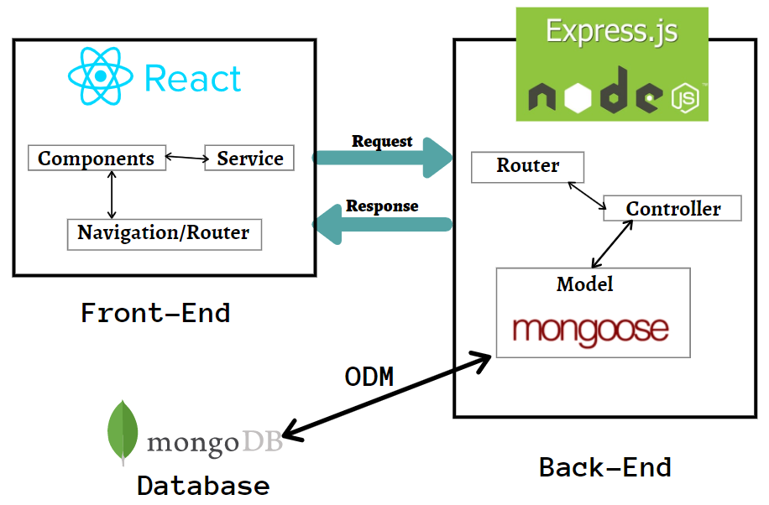

**Explanation:**

* **Front-End:** Represents the user's web browser where the Fit & Fun application runs powered by ReactJS.
* **Back-End:** Represents the application programming interface (API) exposed by the back-end server built using Express JS and Backend Environment is provided by NodeJS.
* **Database:** Represents the MongoDB database that stores user data, workout routines, and progress tracking information.

The system architecture of the Fit & Fun application is designed to ensure scalability, reliability, and a seamless user experience. The architecture comprises both frontend and backend components, each playing a crucial role in the overall functionality of the application.

**Frontend**

The frontend of the Fit & Fun application is developed using React, a popular JavaScript library for building user interfaces. Key features of the frontend architecture include:

1. **Component-Based Architecture:** React's component-based structure allows for reusable and modular code, making the application easier to maintain and extend.
2. **Styled Components:** For a consistent and responsive UI, we utilised styled-components to implement custom styles, ensuring the application looks great on all devices.
3. **Routing:** React Router is used to manage navigation within the application, providing a smooth and dynamic user experience.

**Backend**

The backend of the Fit & Fun application is built using Node.js and Express, providing a robust and scalable server-side architecture. Key features of the backend architecture include:

1. **API Endpoints:** The backend exposes various RESTful API endpoints for handling user authentication, fetching workout plans, and processing other user requests.
2. **Database:** MongoDB is used as the primary database to store user data, workout plans, and other relevant information. MongoDB's flexibility and scalability make it an ideal choice for this application.
3. **Authentication:** JWT (JSON Web Token) is implemented for secure user authentication, ensuring that user data is protected.

**Integration**

The frontend and backend communicate via API calls, enabling dynamic data exchange and real-time updates. This integration ensures that users receive the most up-to-date information, such as workout plans and motivational quotes.

**Security**

Security is a critical aspect of the Fit & Fun application. Key security measures include:

1. **Data Encryption:** All sensitive data, such as passwords, is encrypted to protect against unauthorised access.
2. **Secure API Endpoints:** API endpoints are secured using JWT, ensuring that only authenticated users can access certain resources.
3. **Regular Updates:** The application is regularly updated to address any security vulnerabilities and ensure compliance with best practices.

The system architecture of the Fit & Fun application is designed to provide a seamless and secure user experience, leveraging modern web development practices and technologies.

**Data Flow:**

1. Users interact with the Fit & Fun application interface in their web browser.
2. The browser sends HTTP requests to the application's API.
3. The back-end server (using Express.js) receives the API requests.
4. The server processes the requests, retrieves or stores data from the MongoDB database using Node.js drivers.
5. The server sends responses back to the browser in JSON format.
6. The browser receives the JSON responses and updates the user interface accordingly.

**Benefits of this Architecture:**

* **Separation of Concerns:** This architecture separates the front-end (user interface) from the back-end (business logic and data processing). This promotes modularity, maintainability, and easier development of independent components.
* **Scalability:** The architecture can be easily scaled horizontally by adding more web servers or database servers to handle increased user traffic or data volume.
* **Flexibility:** The API allows for future integration with mobile applications or other services.

**User Interface Design (UI)**

The user interface (UI) of the Fit & Fun application is crafted to provide a clean, intuitive, and engaging experience for users. The design focuses on accessibility, ease of navigation, and a visually appealing aesthetic to encourage users to interact with the application regularly.

**5.1 Key Features of the UI Design**

1. **Landing Page:**
   1. **Hero Section:** The landing page features a hero section with the app's name "Fit & Fun" and a tagline displayed over an attractive background image. This section captures the user's attention immediately.
   2. **Call to Action:** Prominent buttons for "Login" and "Register" are provided to guide new and returning users to the appropriate actions.
2. **Navigation:**
   1. **App Bar:** The app bar includes a menu icon for opening a side drawer, providing quick access to different sections of the application, such as Home, Workout, Planner, and Profile.
   2. **Drawer Menu:** The drawer contains a list of navigational links, each accompanied by an icon for visual clarity. Users can easily navigate to different sections of the app.
3. **Motivational Quotes:**
   1. **Dynamic Quotes Display:** Motivational quotes are dynamically displayed in a visually appealing manner using gradient headings. This feature aims to inspire and motivate users each time they open the app.
4. **ChatBot Integration:**
   1. **AI ChatBot:** The ChatBot is integrated into the application to provide users with interactive assistance. It can answer basic questions, guide users through features, and enhance user engagement.
5. **Profile Page:**
   1. **User Information:** The profile page displays user information, including the profile picture, name, and email address.
   2. **Update Profile:** Users can update their profile details, including their profile picture, through a simple and intuitive form.
6. **Forgot Password:**
   1. **Reset Password Form:** The forgot password feature allows users to request a password reset by entering their email address. A success or error message is displayed based on the outcome of the request.

**5.2 Design Principles**

1. **Consistency:** The UI design maintains consistency in colours, fonts, and button styles across all screens to provide a uniform look and feel.
2. **Accessibility:** The design ensures that the app is accessible to all users, including those with disabilities, by following best practices such as using high-contrast colours and providing alt text for images.
3. **Responsiveness:** The application is designed to be fully responsive, ensuring that it works seamlessly on various devices, including desktops, tablets, and smartphones.
4. **User-Centric Design:** The UI is designed with the user in mind, prioritising ease of use and minimising the number of steps required to perform common actions.

By focusing on these design principles and features, the Fit & Fun application aims to provide a delightful and user-friendly experience that encourages regular use and engagement.

**5.3 User Interface (UI) Screenshots**

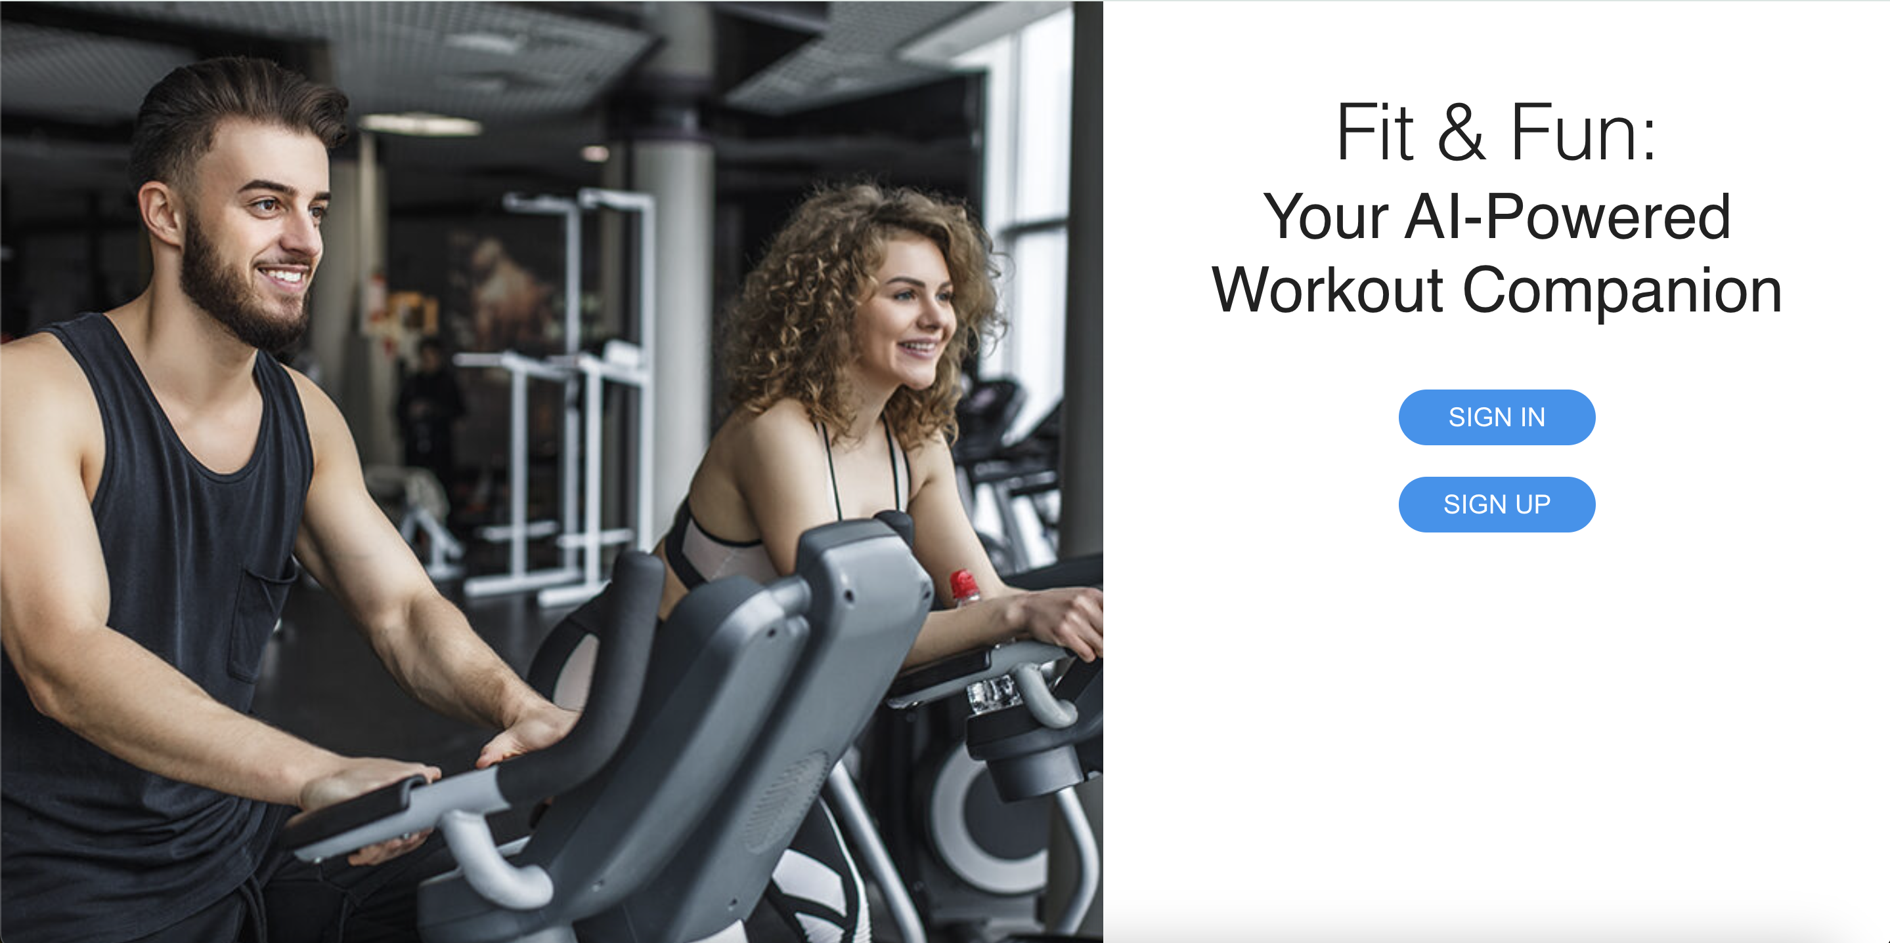

**Landing Page:** The landing page serves as the initial point of contact for users. It should be visually appealing, conveying the essence of the Fit & Fun application and its core functionalities (e.g., personalized workouts, progress tracking).

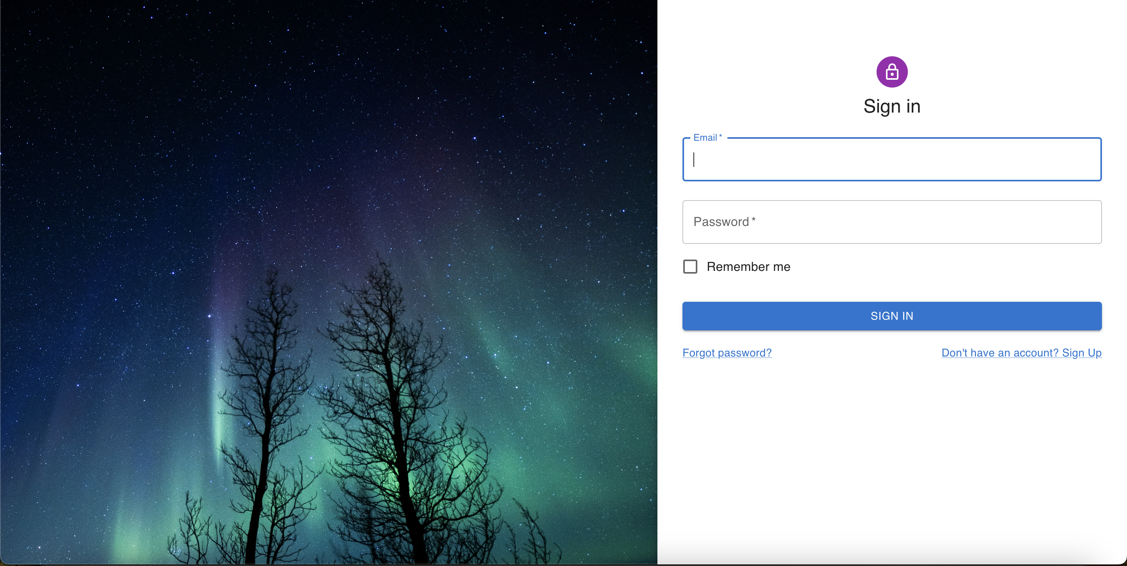

**Login Screen:** The login screen should be user-friendly and secure. Implement features like "Remember Me" for user convenience while adhering to best practices for password security. Visually indicate login success or failure with clear messages for a smooth user experience. (Include a screenshot of the login screen here)

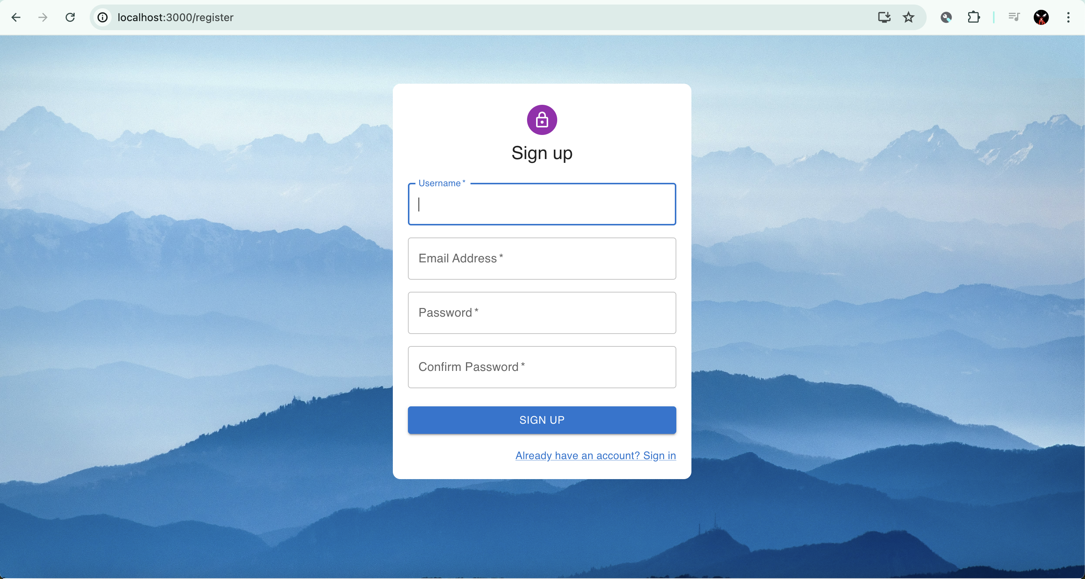

**Registration Form:** The registration form should be straightforward and require only essential information (username, email address, password). Prioritize user privacy by ensuring data collection aligns with the application's purpose. Consider utilizing clear labels and validation to guide users through the registration process effectively. (Include a screenshot of the registration form here)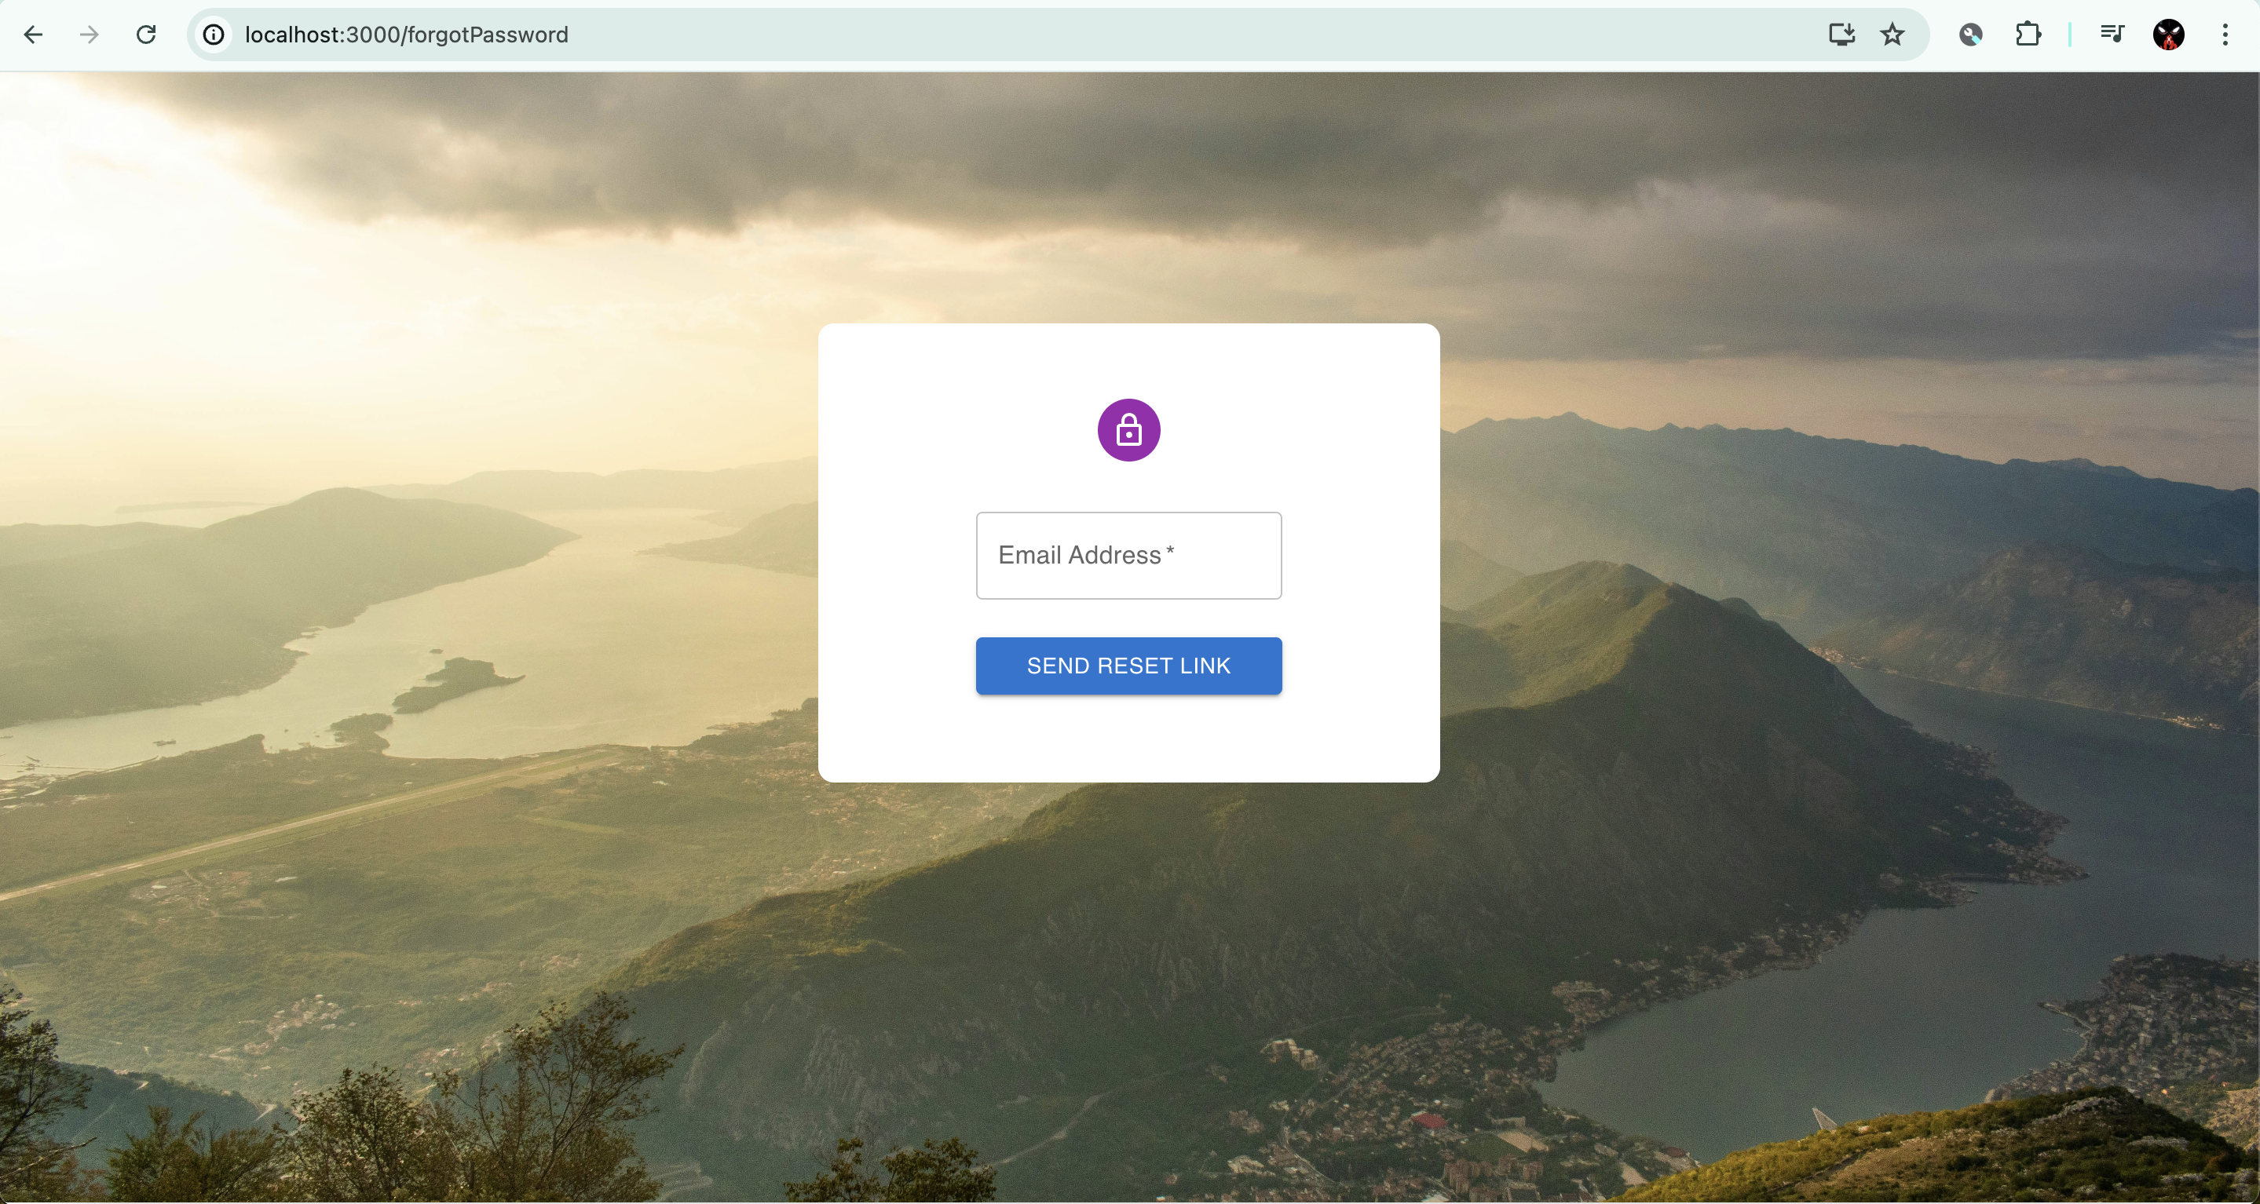

**Forgot Password Page**

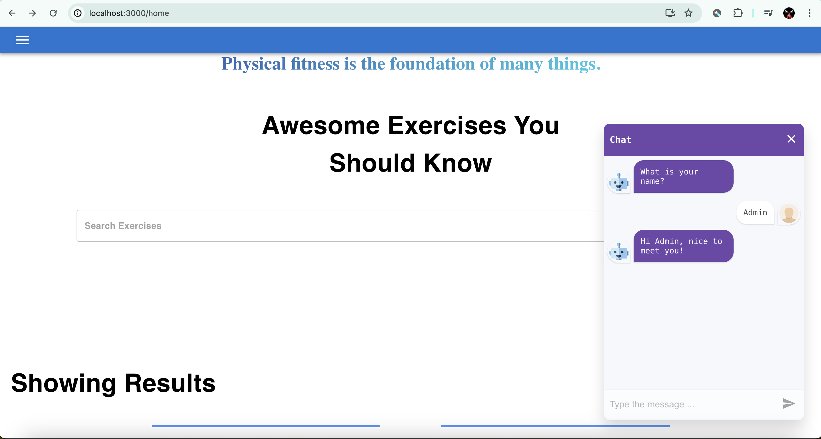

**ChatBot Integration**

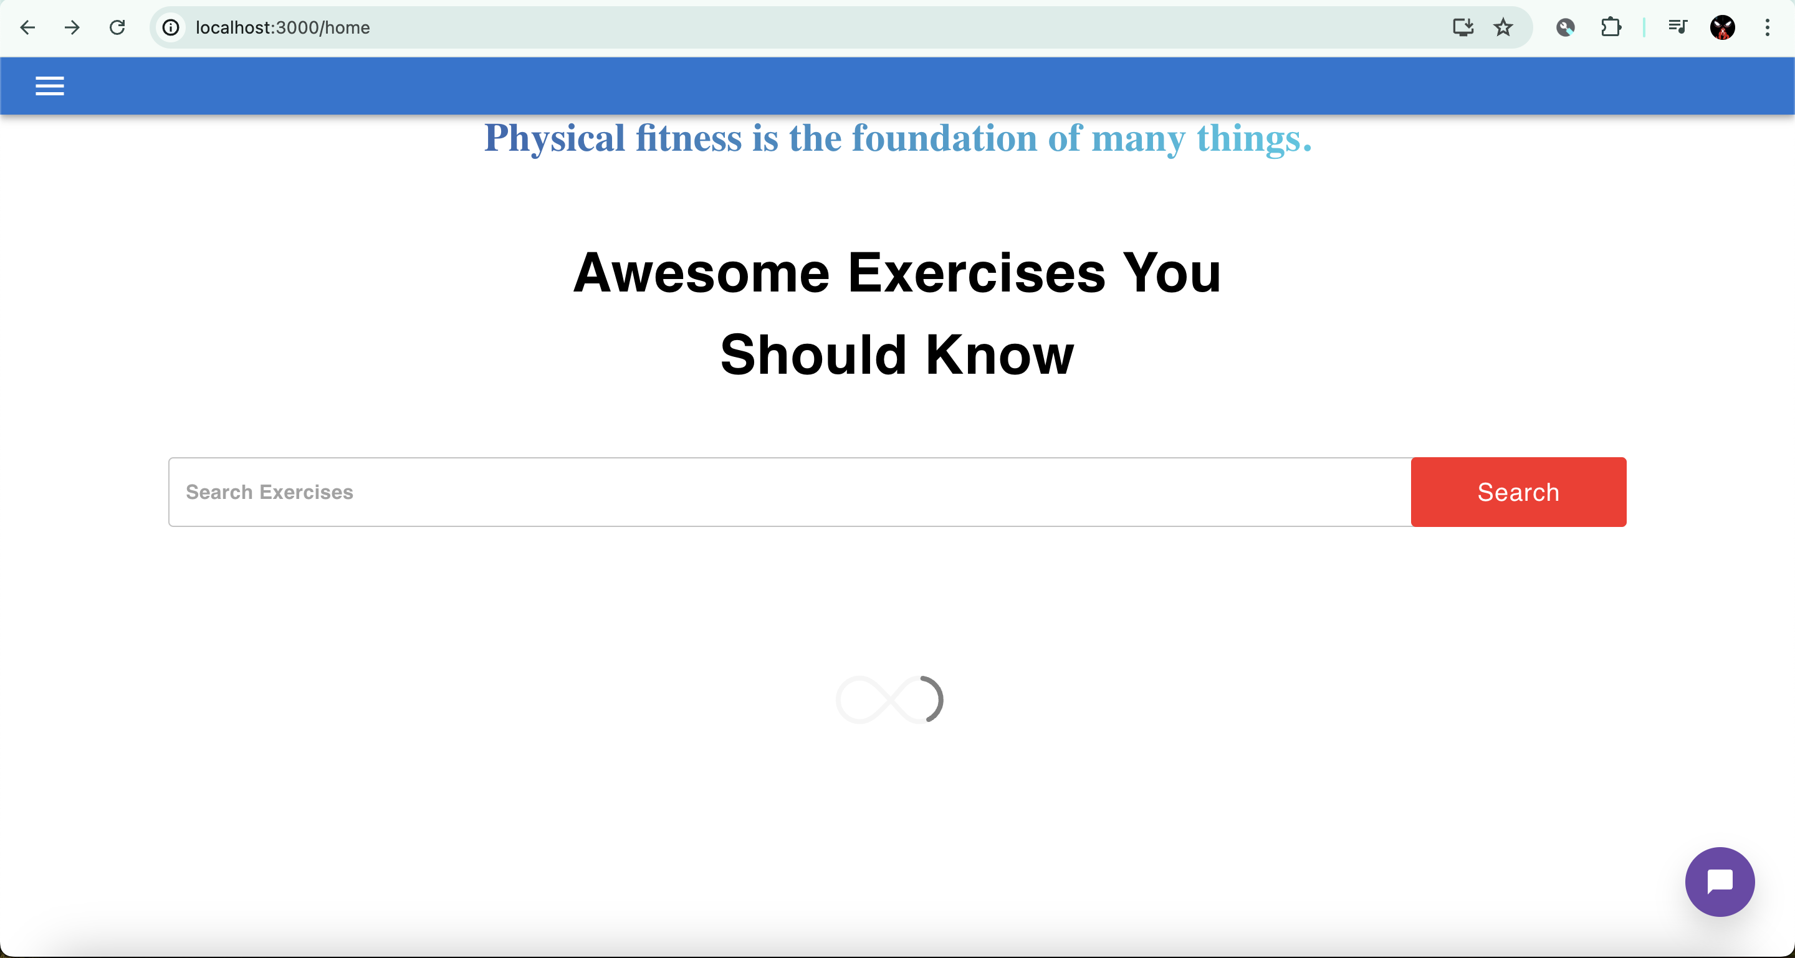

**Home Page**

**App Bar and Sidebar Menu**

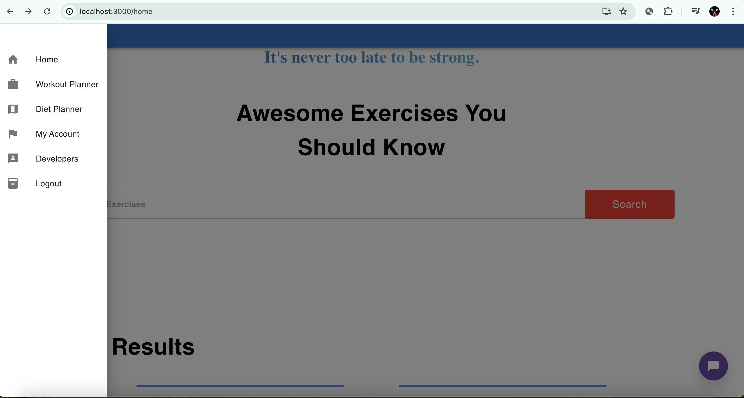

**5.4 Design Choices & User Experience (UX)**

* **Clean and Modern Aesthetic:** A clean and modern aesthetic will enhance the application's usability and appeal to a broad audience. Consider utilizing white space effectively, leveraging a consistent color palette, and employing modern design patterns.
* **Intuitive Navigation:** Effortless navigation is crucial for a positive user experience. We aim to design a clear and intuitive navigation system that allows users to easily access all functionalities of the application, regardless of their technical expertise. This might involve a prominent navigation bar or menu system with easily identifiable icons and labels.
* **Responsive Design:** The Fit & Fun application should adapt seamlessly to different screen sizes and devices (desktops, tablets, smartphones). Responsive design ensures optimal functionality and user experience across various platforms.

These design choices prioritizes user needs and fosters an intuitive and engaging experience for all users. By prioritizing clarity, consistency, and responsiveness, the UI design empowers users to navigate the application effortlessly and leverage its functionalities to achieve their fitness goals.

**5.5 UI Libraries or Frameworks (if applicable)**

In crafting the user interface (UI) for the Fit & Fun application, we leverage the power of Material-UI, a popular React component library based on Google's Material Design principles. This strategic choice empowers us to deliver a user-friendly, visually appealing, and consistent user experience.

**Benefits of Material-UI for Fit & Fun:**

* **Pre-built Components**: Material-UI offers a vast library of pre-built components that mirror the established Material Design language. These components include buttons, text fields, cards, navigation elements, and more. Utilizing these pre-built components significantly streamlines the development process, allowing us to focus on the core functionalities of the Fit & Fun application.
* **Faster Development**: By employing pre-built, customizable components, Material-UI facilitates rapid UI development. This translates to a faster time-to-market for the Fit & Fun application and allows us to prioritize feature development and user experience refinement.
* **Consistent Design Language**: Material Design, the foundation of Material-UI, is renowned for its clean aesthetics, intuitive user interactions, and well-defined visual elements. By adhering to Material Design principles, we ensure a consistent and user-friendly experience across all parts of the Fit & Fun application. This consistency fosters user trust and minimizes the learning curve for new users.
* **Google's Material Icons**: Material-UI seamlessly integrates with Google's Material Icons library. These readily available icons provide a clear and visually appealing way to represent various functionalities within the Fit & Fun application. This not only enhances the user experience but also promotes international usability by leveraging icons that transcend language barriers.

**Backend Development**

The backend integration for the Fit & Fun application is a crucial component that enables data management, user authentication, and interaction with external services. Below are the key aspects of the backend integration

**6.1 Backend Functionalities**

The Fit & Fun application encompasses a variety of features designed to enhance the user experience and support users in their fitness journey. Each feature is carefully implemented to provide functionality, usability, and a seamless experience. Below are the key features implemented in the application:

**1. User Authentication**

* + **Login:** Users can log in to their accounts using their credentials. The login feature ensures secure access and user-specific experiences.
  + **Registration:** New users can create an account by providing necessary details such as name, email, and password.
  + **Forgot Password:** Users who forget their password can request a password reset. An email is sent to them with instructions to reset their password.

**2. Dynamic Motivational Quotes**

* + **Random Quotes Display:** A random motivational quote is displayed each time the user accesses the home page. This feature aims to inspire and motivate users.
  + **Quote Styling:** Quotes are displayed with gradient headings, making them visually appealing and enhancing user engagement.

**3. Navigation and User Interface**

* + **App Bar and Drawer Menu:** An app bar with a menu icon opens a side drawer, providing quick navigation to different sections such as Home, Workout, Planner, and Profile.
  + **Responsive Design:** The UI is fully responsive, ensuring the application works seamlessly on desktops, tablets, and mobile devices.

**4. Profile Management**

* + **Profile Display:** Users can view their profile information, including their profile picture, name, and email address.
  + **Profile Update:** Users can update their profile details. A button on the profile page allows users to change their profile picture and other information.

5. **Interactive ChatBot**

* + **ChatBot Integration:** An AI-powered chatbot is integrated into the application. The chatbot interacts with users, answers their questions, and provides guidance through the app’s features.
  + **User Interaction**: The chatbot initiates conversations, asks for the user's name, and responds with personalised greetings.

6. **Forgot Password**

* + **Reset Password Form:** Users can submit their email to request a password reset. Upon submission, a success message or error message is displayed based on the outcome.

7. **Custom Buttons and Messages**

* + **Styled Buttons:** Buttons with rounded edges are styled using styled-components to enhance the visual appeal.
  + **Success and Error Messages:** Success and error messages are styled to provide clear feedback to the user regarding their actions.

**Technical Implementation**

1. **React and Material-UI:** The application is built using React for the front end, with Material-UI components to ensure a consistent and modern design.
2. **State Management:** React's state management features such as useState and useEffect are used to manage component states and side effects.
3. **Navigation:** React Router DOM is used for navigation between different pages and components within the application.
4. **Styled Components:** styled-components are used to create custom-styled components, ensuring a consistent design system across the application.
5. **Axios:** Axios is used for making HTTP requests to the backend API, such as sending password reset emails.

These features collectively ensure that the Fit & Fun application is not only functional but also user-friendly and engaging, helping users in their fitness journey with a seamless and enjoyable experience. By prioritising secure user authentication and data storage in the initial phase, we have built a strong foundation for future functionalities. The backend will continue to evolve alongside the application, ensuring a robust and scalable platform for users to manage their fitness journeys.

**6.2 Database & Data Models**

The Fit & Fun application utilizes MongoDB, a NoSQL database, to store user data and application information. Here's a breakdown of the key data models implemented:

* **User Model:** This model stores user information such as username, email address, hashed password (using bcrypt), and any additional user-specific data points in the future (e.g., preferences, goals).
* **Workout Model (Future):** This model will store workout details (exercises, sets, reps) once the workout management functionality is implemented.
* **Progress Tracking Model (Future):** This model will store user workout history and progress data, allowing users to visualize their achievements over time.
* **Additional Models (Future):** Depending on future functionalities, additional models might be required to store social connection data (friendships, challenges) or AI-related data (workout recommendations, performance analysis).

The flexibility of MongoDB allows us to easily scale the database as the user base and data volume grow. Additionally, its schema-less design provides the adaptability needed to incorporate future features without significant database schema modifications.

**6.3 Backend Components**

Below are the key aspects of the backend integration:

**1. User Authentication**

* **API Endpoints:** Secure API endpoints are implemented to handle user login, registration, and password reset requests.
* **Token-Based Authentication:** JSON Web Tokens (JWT) are used for authenticating users and maintaining sessions. This ensures that only authenticated users can access certain features of the application.

2. **Profile Management**

* **Update User Profile**: The backend provides endpoints to update user profile information, including profile pictures. When users submit updated details, the backend processes these requests and updates the database accordingly.

**3. Password Reset**

* **Forgot Password Endpoint:** An endpoint is provided to handle forgot password requests. When users request a password reset, an email is sent to them with a secure link to reset their password.
* **Email Service Integration:** An email service (such as SendGrid or a similar service) is integrated with the backend to send password reset emails to users. The email contains a link with a token that allows users to securely reset their password.

4. **Quotes Management**

* **Quotes API:** An API is implemented to fetch motivational quotes from the backend. These quotes are then displayed randomly on the home page.
* **Database Storage:** Motivational quotes are stored in a database and fetched via the API. This allows easy management and updates of quotes without changing the frontend code.

**5. ChatBot Integration**

* **AI ChatBot:** The chatbot functionality is powered by an AI that handles user interactions. The backend facilitates communication between the frontend chatbot interface and the AI service.

**6. Error Handling**

* **Error Responses:** The backend is designed to handle errors gracefully. When an error occurs (e.g., invalid login credentials or server issues), appropriate error messages are sent back to the frontend.
* **Logging:** Error logging is implemented to track and debug issues. Logs help in identifying problems and improving the system.

**6.4 Technical Implementation**

1. **Node.js and Express:** The backend is built using Node.js and Express.js, providing a robust and scalable framework for handling API requests.
2. **Database:** A relational database (such as PostgreSQL or MySQL) is used to store user information, quotes, and other relevant data.
3. **Security:** The backend employs various security measures, including encryption of sensitive data, token-based authentication, and secure password reset links.
4. **Middleware:** Middleware functions are used to handle authentication, validation, and error handling, ensuring clean and maintainable code.
5. **API Documentation:** The backend API is documented using tools like Swagger, allowing easy reference and usage by frontend developers.

**Security Considerations**

Security is paramount for the Fit & Fun application, as it handles sensitive user data like usernames, email addresses, and potentially even future health-related information. We take a proactive approach to securing user data and mitigating potential security risks. Here's a breakdown of the security measures implemented and considerations for future enhancements.

### 7.1 Secure Password Storage (bcrypt)

One of the most critical security measures we've implemented is the use of bcrypt for password hashing. Bcrypt is a robust industry-standard algorithm that encrypts user passwords before storing them in the database. This ensures that passwords are never stored in plain text, significantly reducing the risk of unauthorized access even if a security breach were to occur. If an attacker were to gain access to the database, they would only see a string of meaningless characters representing the hashed password, rendering it useless for malicious purposes.

### 7.2 Additional Security Measures

While bcrypt is a strong foundation for password security, here are some additional security measures to consider for future development:

* **Session Management:** If implemented, ensure secure session management practices. This might involve using secure cookies with appropriate expiration times and HttpOnly flags to prevent unauthorized access.
* **Input Validation:** Rigorous input validation on the backend safeguards against potential security vulnerabilities like SQL injection attacks. Validate all user input thoroughly to prevent malicious code injection attempts.
* **Data Encryption (Optional):** For highly sensitive data (if applicable), consider implementing data encryption at rest and in transit. This adds an extra layer of protection for user information.
* **Regular Security Audits:** Conducting periodic security audits by qualified professionals can identify potential vulnerabilities and ensure the application remains secure.
* **Secure Coding Practices:** Adhere to secure coding practices throughout development to minimize the risk of introducing vulnerabilities through coding errors.
* **Stay Updated:** Maintaining up-to-date software libraries and frameworks on the back-end server is crucial. Updates often include security patches that address newly discovered vulnerabilities.

By prioritizing secure password storage and considering these additional measures, we actively safeguard user data and maintain a high level of security for the Fit & Fun application. We are committed to continuously evaluating security best practices and implementing necessary improvements to ensure a secure and trustworthy environment for our users.

**Conclusion**

The Fit & Fun application is a promising work-in-progress, designed to empower users of all fitness levels to achieve their goals. The initial development phase has established a secure and user-friendly foundation, paving the way for a comprehensive fitness management platform. We successfully implemented core functionalities like user registration, login, and secure password storage using industry-standard practices like bcrypt hashing. The utilization of the MERN stack ensures scalability and flexibility for future development.

A well-defined development methodology, combined with a collaborative workflow and rigorous testing procedures, facilitated efficient development and ensured the quality of the application. The user interface prioritizes intuitive design principles, leveraging Material-UI and Google's Material Design for a clean and user-friendly experience. The secure backend architecture utilizes MongoDB for data storage and offers flexibility to accommodate future functionalities.

**References**

1. Material UI. (n.d.). MUI - React component library. Retrieved June 18, 2024, from <https://mui.com/>
2. MongoDB. (n.d.). MongoDB Atlas Database. Retrieved June 18, 2024, from <https://www.mongodb.com/products/platform/atlas-database>
3. Node.js. (n.d.). Node.js®. Retrieved June 18, 2024, from <https://nodejs.org/en>
4. Open Web Application Security Project (OWASP). (n.d.). OWASP. Retrieved June 18, 2024, from <https://owasp.org/>
5. React.js. (n.d.). React – A JavaScript library for building user interfaces. Retrieved June 18, 2024, from <https://react.dev/>
6. The Agile Alliance. (n.d.). Agile Alliance. Retrieved June 18, 2024, from <https://www.agilealliance.org/>
7. Bcrypt Password Hashing (Example using Django Documentation): <https://docs.djangoproject.com/en/2.0/_modules/django/contrib/auth/hashers/>
8. Express.js. (n.d.). Express.js - Node.js web framework. Retrieved June 18, 2024, from <https://expressjs.com/>
9. JWT.io. (n.d.). JWT.io. Retrieved June 18, 2024, from <https://jwt.io/> (for JWT information)
10. React Icons. (n.d.). React Icons. <https://react-icons.github.io/react-icons/>